1. Explain the 3-Tiered Architecture.

Presentation Tier:

This is where the end user interacts with the application; it is the user interface and communication layer. Informing the user and gathering data from them is its primary goal. For example, this top-tier software can operate via a graphical user interface (GUI), a desktop application, or a web browser. Usually, HTML, CSS, and JavaScript are used to create web presentation tiers. Platform-specific languages can be used to write desktop apps.

Application Tier:

The application's central component, sometimes referred to as the middle tier or logic tier, is the application. Using business logic, or a particular set of business rules, information gathered in the presentation layer is processed in this tier, sometimes in comparison to other information in the data tier. Additional, deleted, or modified data in the data tier can be made by the application tier.Typically, Python, Java, Perl, PHP, or Ruby are used to construct the application layer, which uses API calls to connect with the data tier.

Data Tier:

The data tier, often referred to as the database tier, data access tier, or back-end, is where the application's processed data is kept and organized. A NoSQL database server like Cassandra, CouchDB, or MongoDB, or a relational database management system like PostgreSQL, MySQL, MariaDB, Oracle, DB2, Informix, or Microsoft SQL Server, can be used for this.

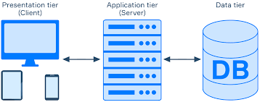

1. What to you understand by web browsers and web server in your own language.

An application called a web browser is used to access the World Wide Web.

World Wide Web. When someone accesses a website with a web browser, the web browser then retrieves and displays the data on the user's screen from the web server. A few Web browsers include, among others, Google Chrome, Opera, Safari, and Brave.

Software and hardware that support HTTP (Hypertext Transfer Protocol) are referred to as web servers.

Includes other protocols to address the queries made by users via the Internet. It

allows for physical data interchange with other devices and has an Internet connection linked to the internet

1. XML Vs. JSON

Data representations utilized in data interchange between are JSON and XML applications. Both can read JSON, which is an open data interchange standard.   
as well as devices. JSON is a popular format that works with any computer language.   
output from APIs in many different apps. One markup language, XML, offers   
guidelines for defining any data. Tags are used to distinguish between the data properties and the   
real information. Although data interchange occurs in both formats, JSON is the more recent and   
more widely used and adaptable choice.   
XML: It was intended to transport data, not show data. The W3C recommends it.   
One markup language that specifies a set of guidelines is called Extensible Markup Language (XML). for encoding documents into a machine- and human-readable format   
readable. XML's design objectives are centered on usability, universality, and simplicity throughout the Internet.   
JSON: It is a completely language-neutral, lightweight data-interchange format.   
independent. It is simple to use and is based on the JavaScript programming language.   
comprehend and produce.

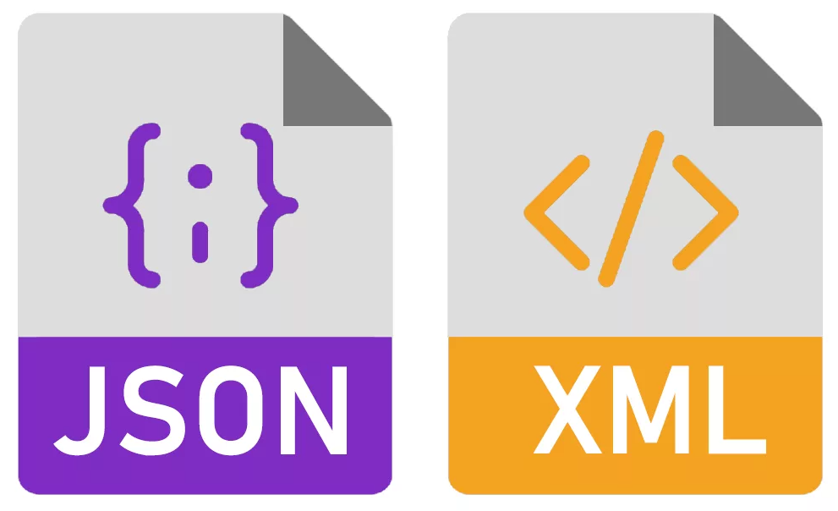

4. Design a page having suitable background color and text color with title “My

First Web Page” using all the attributes of the Font tag.

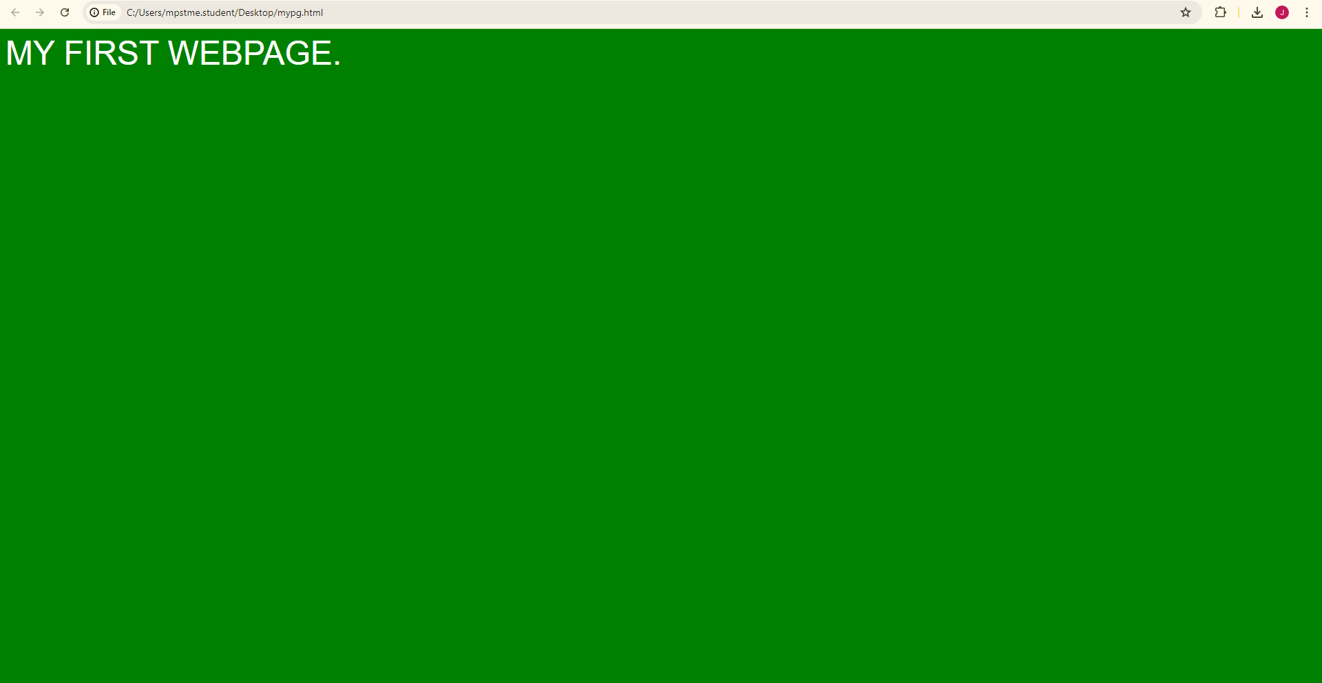

5.Create a HTML document giving details of your [Name, Age], [Address, Phone] and [Register Number, Class] aligned in proper order using alignment attributes of Paragraph tag.

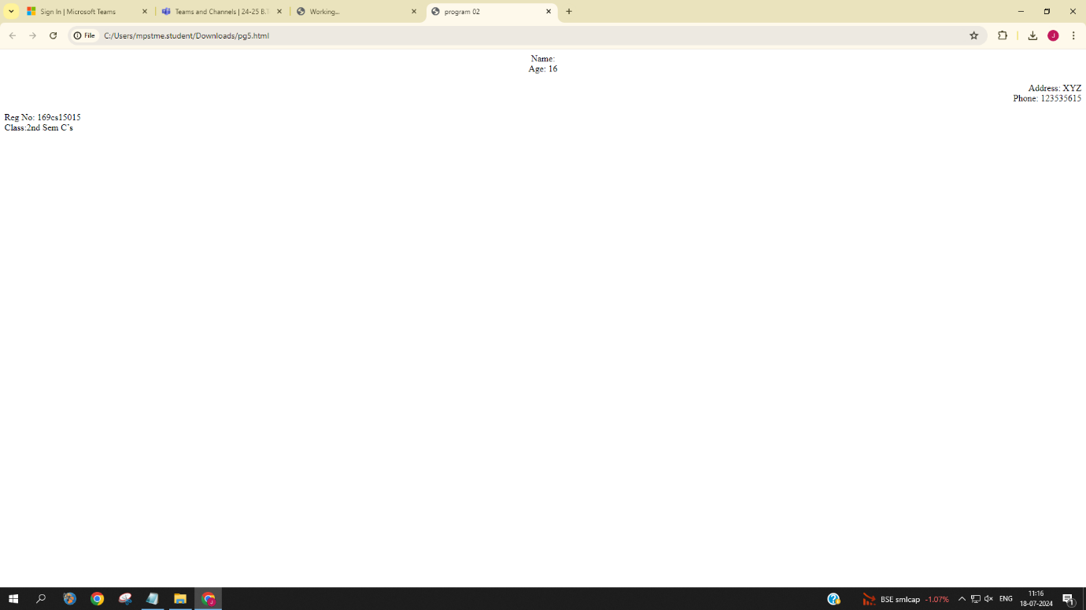

6.Write HTML code to design a page containing some text in a paragraph by giving suitable heading style. 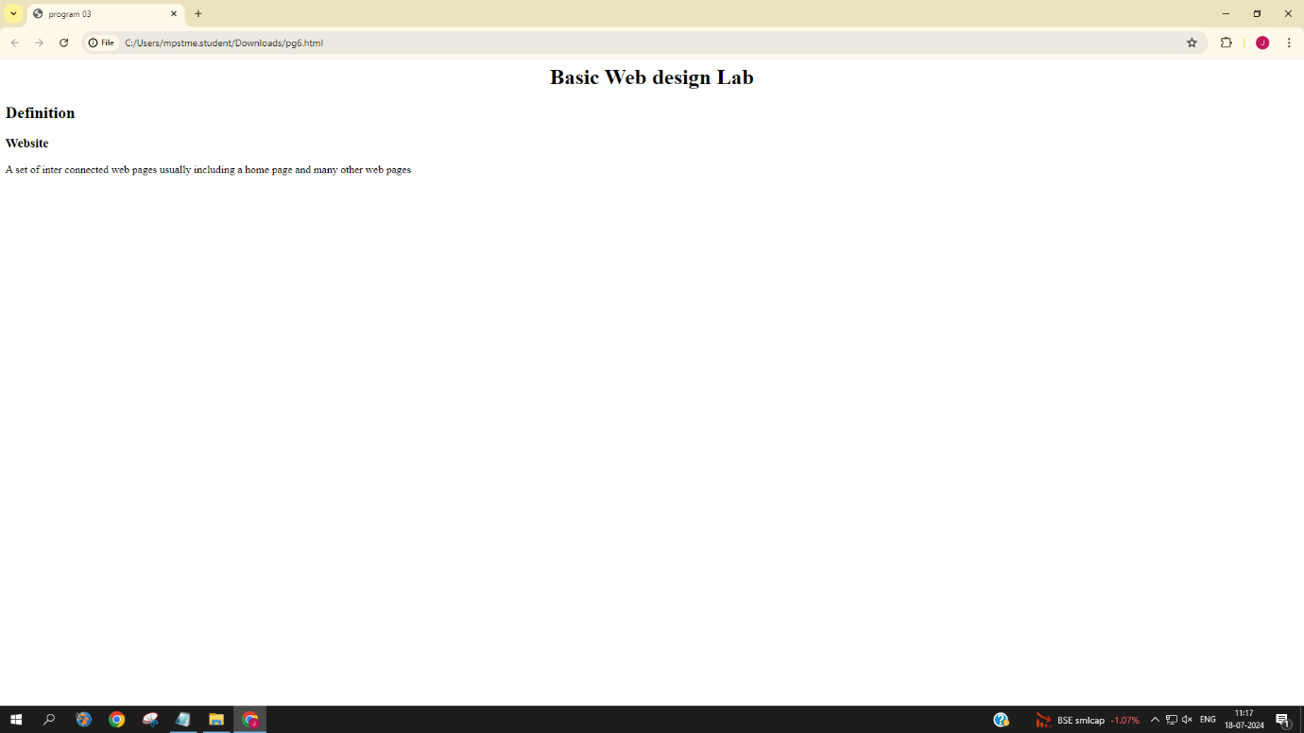

7.Create a page to show different character formatting (B, I, U, SUB, SUP) tags.

*viz :* *log* bmp= p *log*bm

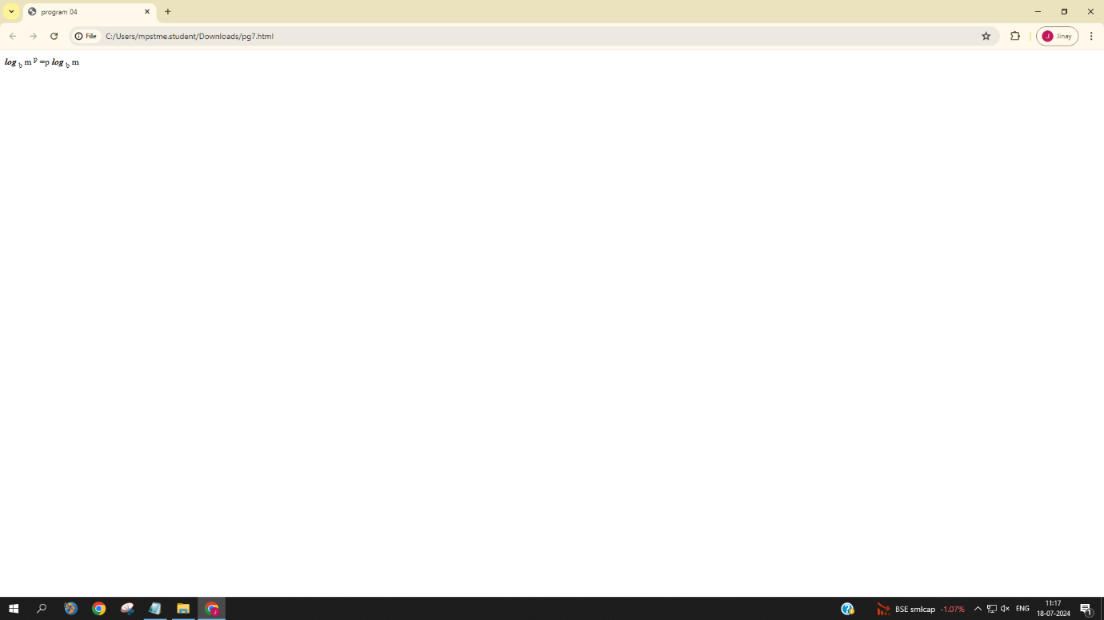

8.Write a HTML code to create a web page with pink color background and display moving message in red color.

